BENEFITS SEGMENT:
a. Number of occurrences cannot exceed 10 and must equal the Number of Benefits
(DN0288).
b. Only one Benefits segment per Benefit Type Code is allowed. The applicable Benefit Type
Code (DN0085) must be included when this segment is present in the transaction.
c. A Benefit Type Code cannot be required with spaces or zeros in the corresponding Benefit
Type Amount Paid.
d. If indemnity benefits have been paid, this segment should be included in each SROI
transaction and is populated with the current values at the time of transmission based upon
the jurisdiction’s Data Element Requirements table for the Benefit Type Codes indicated on
the Population Restrictions tab of the jurisdiction’s Edit Matrix. The following table illustrates
the minimum number of Benefits segments that should be expected for each SROI MTC.
The exception to this would be that if all indemnity checks have been returned/cancelled/
voided and Recovery Code 880 is present or if the Reduced Benefit Amount Code “S”,
“N”, or “Z” is present, a Benefits segment may not be present on the transaction. A Benefit
Segment previously reported, or the amount of Indemnity benefits paid on a claim may be
fully or partially reduced from the Benefit Type Amount Paid that was previously reported if
Reduced Benefit Amount Code “D” is present.
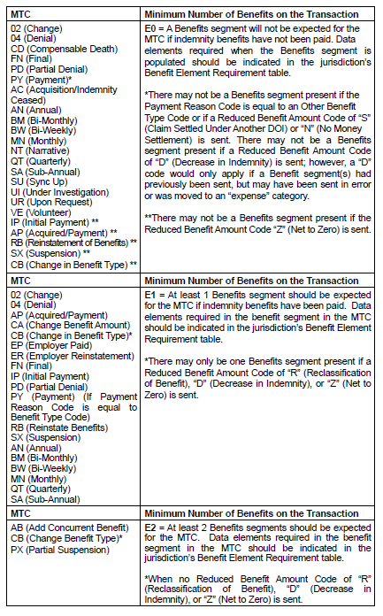
There are two different ways of populating the Benefits segment depending upon whether the
Benefit Type Code is related to the “Event” (MTC currently being reported) or is just being sent as
“sweep” data. See the following sections “e” and “f” for the population rules.

e. “Event” Benefits Segment Rules: The Maintenance Type Code (MTC) occurs twice in
the Subsequent Report Record Layout (once in the A49 record and once in the Benefits
segment of the R22 Companion record). The MTC in the A49 record is considered “Claim
Level” and identifies the type of transaction being sent, and the MTC in the Benefits
segment of the R22 Companion record is considered “Benefit Level” and identifies the
benefits that are being affected by this transaction.
The following rules should be used to determine when an MTC should be reported in a
Benefits Segment. The MTC is reported in a Benefits segment in order to identify the
Benefit Type(s) that is being affected by this “Event” (MTC).

MTC in the Benefits Segment:
The MTC(s) in the Benefits Segment must be the same as the MTC at the Claim
Level of the transaction and should be reported when:
• A Benefit Type Code is starting, changing, or being partially suspended
• A lump sum payment is being reported with Benefit Type Code 0XX
• A Benefit Type Code is starting, changing, or being suspended and the
Gross/Net Weekly Amount is being changed for any Benefits segment(s)
previously ended (i.e. rate change retroactive to all previously paid benefit
types).
• When reporting a Sync Up (SU) MTC
The following MTCs are to be sent in the Benefits segment of the affected Benefit(s).
These are known as “Event” Benefits segments and are populated based upon the
jurisdiction’s Event Benefits Segment Requirements table.
• The benefit being initiated (AB, AP, CB, EP, ER, IP, or RB,) and/or;
• The benefit amount being changed (CA) and/or;
• The data in the specific Benefits segment occurrence being changed (02 - ^Includes Benefit Type Code 5XX, unless another MTC applies)
• The benefit(s) being terminated (CB, PX, SX)
• The lump sum payment (Benefit Type Code 0XX) being reported (PY)
• Corrections (CO) that are being made to any of the above MTCs
• On all benefit segments reported on the Sync Up (SU) MTC
*Population of the Benefits Segment for Employer Paid benefits differs from all
other “Event” Benefits segment. Refer to Employer Paid Population Rules (i.) for
details.
^Population of the Benefits Segment for Benefit Type 5XX differs from all other “Event” Benefits segment. Refer to Lump Sum Payments/Settlements Population Rules (h.) for details.

If some, but not all indemnity checks have been returned/cancelled/voided, at least 1 Benefit
segment will be present along with Recovery Code 880, and the Benefit Type Amount Paid will
be less the amount of the indemnity checks that were returned/cancelled/voided. The Benefit
Type Amount Paid will reflect the amount that was actually paid out, but the other DNs in the
Benefits segment may or may not be retroactively adjusted, and should not be edited to match
the Benefit Type Amount Paid.
If indemnity benefits were decreased from the amount previously reported, not due to a
reclassification of benefits, the Reduced Benefit Amount Code “D” will be present, and the
Benefit Type Code previously reported, may or may not be present. If indemnity benefits were
reclassified, the Reduced Benefit Amount Code “R” will be present, and the Benefit Type Code
previously reported, may or may not be present. The Benefit segment(s) reported will include
the Benefit Type Amount Paid which will reflect the actual reclassified amount.
“Sweep” Benefits Segment Rules: Whenever a different Benefit Type Code has been
paid that does not contain the MTC at the Benefit Level, aggregate financial information is
sent as part of a “Sweep” Benefits Segment. The reported “sweep” information is limited
to the data elements in the Benefits Segment as listed below. Jurisdictions should ignore
and not edit or reject transactions with any data elements they do not require.
No MTC in the Benefits Segment:
When an MTC applies to the claim as a whole, the MTC is sent at the Claim Level
only (A49 record) and is not populated in the Benefits Segment (i.e., a Denial
applies to all Benefit Type Codes, and thus the MTC is not sent in the Benefits
Segment.)
MTCs at the Claim Level apply to the following MTCs:
• SROIs: 02 (When a specific benefit segment occurrence is not changing), 04, FN, PY (Benefit Type Code 5XX series), PD, and UR, (and any CO that is correcting these MTCs)
• Periodics: AN, BM, BW, MN, QT, and SA
A “Sweep” Benefits Segment must include the following data elements:
• Benefit Type Code (DN0085)
• Benefit Type Amount Paid (DN0086)
• Benefit Type Claim Weeks (DN0090) (Cannot be required when Benefit Type Code =
5XX)
• Benefit Type Claim Days (DN0091) (Cannot be required when Benefit Type Code =
5XX)
• Benefit Period Start Date (DN0088) - refer to the definition in the dictionary to
determine whether this should be reset
• Benefit Period Through Date (DN0089)
A “Sweep” Benefits Segment cannot be required to include the following data elements:
• Gross Weekly Amount (DN0174)
• Gross Weekly Amount Effective Date (DN0175)
• Net Weekly Amount (DN0087)
• Net Weekly Amount Effective Date (DN0211)
• Benefit Payment Issue Date (DN0192)
A “Sweep” Benefits Segment will not include the following data element:
• MTC (DN0002)
If some, but not all indemnity checks have been returned/cancelled/voided, at least 1 Benefit
segment will be present along with Recovery Code 880, and the Benefit Type Amount Paid will be
less the amount of the indemnity checks that were returned/cancelled/voided. The Benefit Type
Amount Paid will reflect the amount that was actually paid out, but the other DNs in the Benefits
segment may or may not be retroactively adjusted, and should not be edited to match the Benefit
Type Amount Paid.
If indemnity benefits were decreased from the amount previously reported, not due to a
reclassification of benefits, the Reduced Benefit Amount Code “D” will be present, and the Benefit
Type Code previously reported may or may not be present. If indemnity benefits were reclassified,
the Reduced Benefit Amount Code “R” will be present, and the Benefit Type Code previously
reported may or may not be present. The Benefit segment(s) reported will include the Benefit Type
Amount Paid which will reflect the actual reclassified amount.

g. Reduced Earnings Population Rules in the Benefits Segment: Whenever the MTC is
required in the Benefits segment for an 070 Benefit Type Code (“Event” Benefits Segment)
and multiple weeks of Temporary Partial benefits are being reported, the Gross Weekly
Amount (DN0174), Gross Weekly Amount Effective Date (DN0175), Net Weekly Amount
(DN0087), and Net Weekly Amount Effective Date (DN0211) in the Benefits segment will
represent the most current Temporary Partial rate and date reported for which benefits
were paid.
h. Lump Sum Payments/Settlements:
• All lump sum payments/settlements are reported on a PY transaction (see Lump
Sum Payment/Settlement Rules). If the Benefit Type Code is 0XX, the Benefits
Segment of the transaction is populated as an “Event” Benefits segment as well as a
Payments Segment. The Benefit Type Code in the “Event” Benefits segment should
be the same as the Payment Reason Code in the Payments segment.
• When a lump sum payment/settlement is reported with a Benefit Type Code of 5XX,
the Benefits Segment of the transaction is populated as a “Sweep” Benefits segment
as well as a Payments Segment. The Benefit Type Code in the “Sweep” Benefits
segment should be the same as the Payment Reason Code in the Payments
segment.
• When populating Benefit Type Code 5XX on MTC SU (Sync Up) or MTC SROI 02 (Change), the 5XX will be reported as a sweep with the exception of the MTC in the benefit segment. The MTC is required at the benefit level on a 5XX benefit on the SU at all times and on the SROI 02 when the 5XX benefit has changed. See Section 4 – Sync Up Processing Guidelines 2 c. and 02 Change Processing Rules, Benefit Processing Rule viii. for more information.)
• If Reduced Benefit Amount Code “S” is present, this means this date of injury has
been settled as part of another settlement under a different date of injury, and a
Benefits Segment will not be present on the transaction unless indemnity benefits had
been paid for this date of injury prior to the settlement. If required by the jurisdiction,
the Award/Order Dates and Lump Sum Payment/Settlement Codes would be the
same for all files settled under one amount/date of injury.
• If Reduced Benefit Amount Code “N” is present, this means that the workers’
compensation claim has been settled, but no settlement monies are being paid.
Therefore, a Payments segment will not be present on the transaction and a Benefits
segment will only be present if indemnity benefits had been paid for this date of injury
prior to the settlement. If required by the jurisdiction, the Award/Order Date and
Lump Sum Payment/Settlement Code would be sent.
i. Employer Paid Population Rules: The following are the data population rules to be
followed when the employer is continuing salary in lieu of workers’ compensation benefits.
Salary continuation is reported as a 2xx Benefit Type Code (DN0085).
Unless excluded in the Population Restrictions tab of the jurisdiction’s Edit Matrix, codes
210, 220, 221, 230, 242, 250, 251, 270 should be used if the claim administrator knows
the specific benefit type for which the injured worker is being paid. Otherwise, code 240
should be used.
Depending upon jurisdiction requirements, it is possible to receive the generic Benefit Type
Code 240 as well as the specific Benefit Type Codes 210, 220, 221, 230, 242, 250, 251,
or 270 on the same transaction. MTC Code CB should be used when changing from any
2XX Benefit Type Code to any other 2XX Benefit Type Code, however, the Event Benefit
Segments of the CB must comply with the chart below.
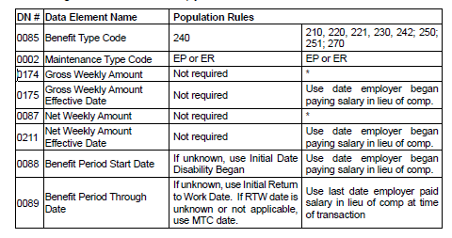
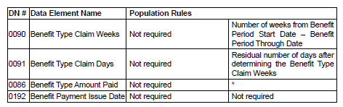
*Since workers’ compensation benefits are not taxable, these fields should be reported using the
amounts that would have been paid under workers’ comp.
Exception: If a jurisdiction requires DN0409 (Weekly Income Amount for Offset) which is present
in the ACR segment, then the amount the employer is paying must be reported using the IP or RB
with 0XX benefits and Benefit Credit Code = M.
j. Net to Zero population rules: The following are data population rules when the Net Weekly
Amount of a benefit (0xx) due by the claim administrator is zero due to an adjustment,
credit, or reduced earnings.
• If the benefit type that is due has immediately net to zero, meaning the claim
administrator has not made any payments on that benefit type code, the benefit
segment may not be present.
o An ACR segment will be present along with the Reduced Benefit Amount
Code = Z to provide jurisdictions the information they need to identify the
benefit has net to zero and no prior payments have been made by the
claim administrator for that benefit type code.
o A Reduced Earnings segment will be present along with the Reduced
Benefit Amount Code = Z to provide jurisdictions the information they
need to identify the 070 benefit is due, but no payments are being made
by the claim administrator because the injured worker’s earnings are
greater than their comp rate.
• If the benefit type nets to zero after payments have been issued by the claim
administrator, a MTC CA (Change in Amount) should be used. Jurisdictions shall
not edit on any data in the benefit segment when Reduced Benefit Amount Code =
Z is present.
• If an adjustment, credit, or reduced earnings changes where benefits are now due
and the Benefit Type Code has not changed, Reduced Benefit Amount Code Z will
be removed and MTC CA would be due.
• If the adjustment, credit, or reduced earnings ends where the associated benefit is
no longer due, Reduced Benefit Amount Code Z will be removed and MTC SX would
be due.
• A Payment Segment cannot be required when a benefit nets to zero due to either
the Benefit Segment not being present because no payments have been made by
the Claim Administrator for that Benefit Type Code or the benefit has net to zero
resulting in a CA Change in Amount MTC.
• It is recommended that Jurisdictions consider requiring a Periodic MTC so benefits
can be identified as ongoing even though dates may not appear to be advancing due
to a net to zero situation.
• Employer Paid Benefits – Jurisdictions who require Weekly Income Amount for Offset
(DN0409) will use Benefit Credit Code “M - Credit for Employer Provided Benefits
in Excess of Covered Weekly Benefit”. Refer to M code definition or Employer Paid
population rules above.

